How to Find an Apprenticeship
https://www.findapprenticeship.service.gov.uk/apprenticeshipsearch
If you click the Help? (Interactive walk through) on the right of the screen.
You will be presented with the screen below.
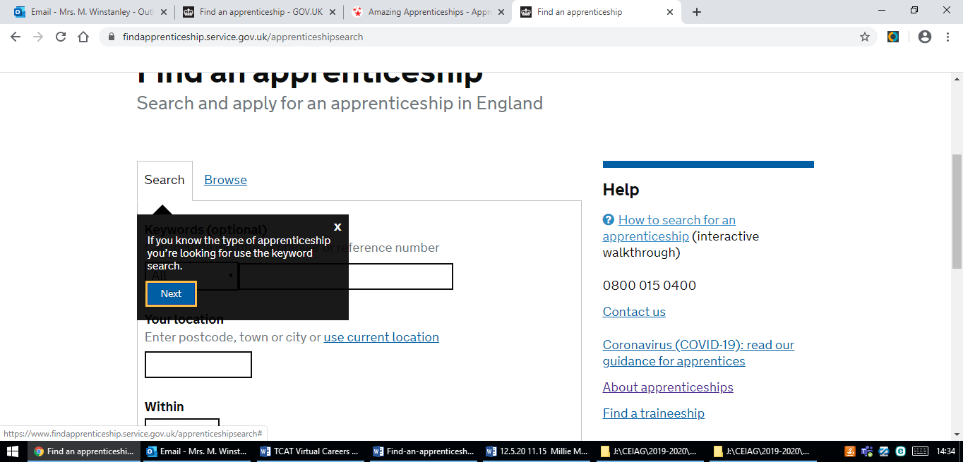
Complete the boxes by using the Help Facility and do some different searches.
See what apprenticeships are available in your area. Alter things like the number of miles you are prepared to travel and see how the availability changes.
Look at the details of some apprenticeships:
- What skills are the employers looking for?
- What qualifications are needed to apply?
- Is this something that may interest you?
- How do the employers expect you to apply?
As a result of the Apprenticeship Section of the TCAT Virtual Careers Day you now know:
1.What an Apprenticeship is.
2. How to find an apprenticeship.
3. To apply to college for a course in case you do not get an Apprenticeship.
4. That Employers approach colleges for apprentices as well as trying to find them themselves.

