Blog Post – Helen Watson, Professional Lead for Children’s Occupational Therapy, 28th May 2019

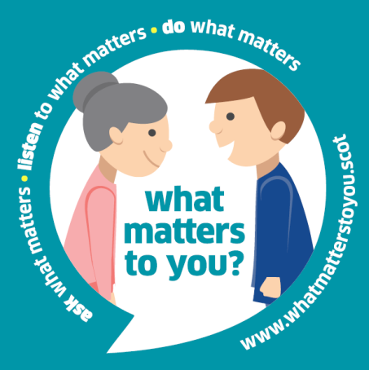
It was with some trepidation that I decided to watch the Panorama programme on the abuse at Whorlton Hall in Durham – a residential setting for adults with learning disability, complex needs and autism. I’m sure I echo the views of all in SCFT who may have seen this when I say how shocked and disturbed I was at the cruelty displayed and the total disregard for the basic human rights and needs of this group of very vulnerable people. It made me appreciate the value of Compassionate Care which is at the heart of this Trust, and I am pleased to say that I witness this on a daily basis from staff both to each other and to the people who use our services. The people and teams I work with are a testament to the caring culture which should be a fundamental part of our practice. When perceived threats to service delivery are presented to them they are the first to advocate for the needs of the children and families they work with and respond with innovation and commitment to doing the best they can within the resources they have. With this in mind I am particularly drawn to the “What Matters To You” initiative which aims to encourage and support more meaningful conversations between providers and people who use services, and which seems to me to be central to delivering compassionate care. It is the simplicity of this question which makes it powerful, and it struck me that as an Occupational Therapist this has always been at the centre of our training and our ethos. I’m proud to say that Occupational Therapists as a profession have always been leaders in championing this very basic principle of care. Occupation is at the centre of our profession and Occupation is essentially “what matters to you”. However this simple question can often get lost in the variety of and increasingly intricate interventions we provide to some of the children and families with the most complex needs. This initiative encourages us to get back to basics. And there are a number of ways we can embed this into our work. The WMTY day on 6th June is an opportunity to stop and think a little more about how we are listening, who we are listening to and what we are doing as a result.

What a tragedy that this concept was a world away from the culture of cruelty displayed by some of the staff identified in the Panorama programme. But let’s celebrate the compassionate care that we can be proud of in this Trust and keep it going by getting involved in the conversation which starts with “What Matters to You?” And let’s also not forget that this question can be applied to our staff and teams to ensure that we have a workforce that feels valued

You can join in 'What matters to you?' day an individual or as a team.
- Complete the online registration form to tell us how you are taking part.
- Have a ‘What matters to you?’ conversation with at least one person on or around 6 June.
- Reflect on how it felt and what happened as a result.
- Come back and share your experience of having the conversation so that we in turn can share your learning with others.
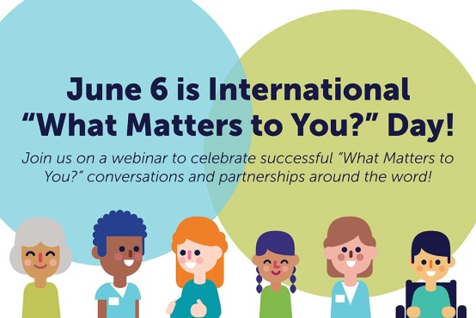
You can also order or download resources to help promote the day in your organisation, department or team.

