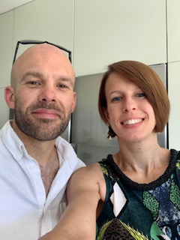

I am a band 6 physiotherapist working within the Community Neuro Rehabilitation Team. Our multidiscipline team consists of a variety of professionals including occupational therapists, speech and language therapists, specialist nurses and a psychologist. Our team look after patients with neurological conditions.

**09.00.40**

My day starts at 8am. Since the pandemic we are all much more agile so I often start at home which helps with my work life balance and getting my three kids off to childcare and school. Usually I would be sorting emails, planning my day and reading notes.

By 9.30 I am usually visiting people in the community. An average day would have 3-4 visits. Today my client is a 45 year old gentleman who has had a large cerebellar bleed. He is in a nursing home and was having to be hoisted, but following rehabilitation he has regained his mobility and we are working with social services and an occupational therapist to find him suitable long term accommodation.

10.45am visit to a lady who has had a stroke, her goals involve regaining a standing transfer and we are working towards enabling better access in and out of her property.

12.00 – I visit a new client who has recently been discharged from hospital following a stroke. We complete a new patient assessment and set goals for her recovery.

13.45 – Today I am having lunch at home. Lunch is flexible in this role, there is no set time sometimes I grab a sandwich and sit on the beach.

14.15 – The rest of the afternoon is spent ordering equipment, doing emails, making exercise programmes, booking in new clients, liaising with orthotics, social services and other colleagues. As well as writing up my notes from the morning.

16.00 - Finish

**10.00.40**

**11.00.40**

**12.00.40**

**13.00.40**

**14.00.40**

**16.00.40**

**15.00.40**