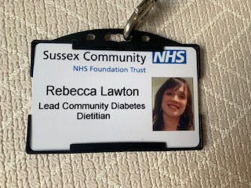

Diabetes Care for You is a community based service in which the dietitians work closely alongside consultants, diabetes specialist nurses, specialist psychotherapists and podiatrists, to support individuals with the management of their diabetes. This includes providing initial education and ongoing support for more complex patients. We provide a holistic approach, taking into account other health conditions and dietary needs.

9am-9.30am: Clinical cases multi-disciplinary team (MDT) meeting. This provides a time for us to discuss any patients in need of MDT input and to discuss a way forward.

10am-1pm: Diabetes Education Group, this is one of my favourite parts of the job, as the patients learn so much from each other as well as from the professionals. These are very interactive and include lots of activities and open discussion. We provide structured education for a range of topics:

* For patients newly diagnosed with type 2 diabetes to help empower them to manage their condition
* Carbohydrate awareness to help people who want to understand more about how carbohydrates impacts on their blood glucose levels
* Carbohydrate counting for those who need to adjust their insulin doses according to what they eat
* BHITE, an intensive type 1 education group

1-1.30pm: Lunch

1.30pm-3.30pm: Clinic – providing one to one support. This is usually face to face, but can be over the phone, video or a home visit. Patients may request support with a wide range of topics such as help to lose or gain weight, help with improving blood glucose control, carbohydrate counting or carbohydrate awareness, or advice to help prevent hypoglycaemia (low blood sugar). Patients may have other conditions which need consideration, for example coeliac disease requiring a gluten free diet.

3.30pm: Time for admin, service development work, such as developing resources or service evaluation

**09.00.40**

**10.00.40**





**13.00.40**



**15.3040**

**13.30.40**