CV Writing Workshop

Using the correct language
Using the correct language in your CV helps to establish you as a professional and competent candidate. Below are examples of words you should consider using in your CV, which have been split into four categories depending on what skills you’re trying to convey.
Management/Leadership Skills
administered | emphasised |  | motivated |  |  | coordinated
analysed | enforced |  | organised |  |  | decided
appointed | enhanced |  | originated |  |  | delegated
approved | established |  | overhauled |  |  | developed
assigned | executed |  | oversaw |  |  | directed
attained | generated |  | planned |  |  | eliminated
authorised | handled |  | presided |  |  | initiated
chaired | headed |  | prioritised |  |  | inspected
considered | hired |  | produced |  |  | instituted
consolidated | hosted |  | recommended |  |  | led
contracted | improved |  | reorganised |  |  | managed
controlled | incorporated |  | replaced |  |  | merged
converted | increased |  | restored |  |  | reviewed
coordinated | initiated |  | reviewed |  |  | scheduled
decided | inspected |  | scheduled |  |  | streamlined
strengthened | supervised |  | terminated |  |  | strengthened
Communication/People Skills
addressed |  | drafted |  | outlined | discussed
advertised |  | edited |  | participated | directed
arbitrated |  | elicited |  | persuaded | negotiated
arranged |  | enlisted |  | presented | observed
articulated |  | explained |  | promoted | wrote
authored |  | expressed |  | proposed | translated
clarified |  | formulated |  | publicised | moderated
collaborated |  | furnished |  | reconciled | developed
communicated |  | incorporated |  | recruited | described
composed |  | influenced |  | referred | mediated
condensed |  | interacted |  | reinforced | synthesised
conferred |  | interpreted |  | reported | defined
consulted |  | interviewed |  | resolved | marketed
contacted |  | involved |  | responded | summarised
conveyed |  | joined |  | solicited | debated
convinced |  | judged |  | specified | listened
corresponded |  | lectured |  | spoke | suggested

Creative skills
acted | drew | invented
adapted | entertained | modelled
began | established | modified
combined | fashioned | originated
condensed | formulated | performed
created | founded | photographed
customised | illustrated | planned
designed | initiated | revised
developed | instituted | revitalised
directed | integrated | shaped
displayed | introduced | solved

Organisation/Detail Skills
approved | incorporated | reserved
arranged | inspected | responded
catalogued | logged | reviewed
categorised | maintained | routed
charted | monitored | scheduled
classified | obtained | screened
coded | operated | set up
collected | ordered | submitted
compiled | organised | supplied
corresponded | prepared | standardised
distributed | processed | systematised
executed | provided | updated
filed | purchased | validated
generated | recorded | verified
implemented | registered

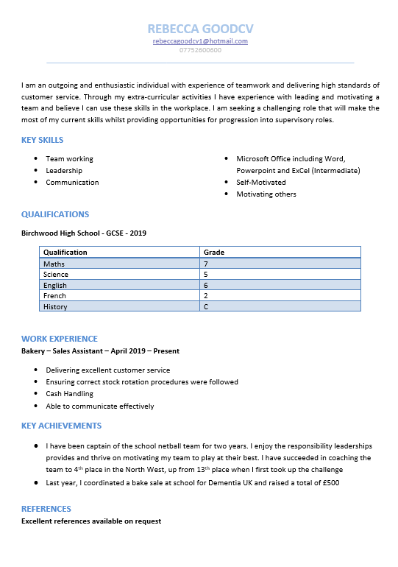

Writing your CV

Personal Details and Personal Statement

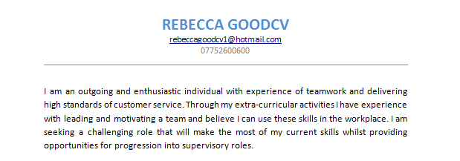
___________________________________________________________________________________________________________________________________________________________________________________________________________________________________________________________________________________________________________________________________________________________________________________________________________________________________________________________________________________________________________________________________________________________________________________________________________________________________________________________________________________________________________________________________________________________________________________________________________________________________________________________________________________________________________________________________________________________________________________________________________________________________________________________________________________________________________________________________________________________________________________________________________________________________________________________________________________________________________________________________________________________________________________________________________________________________________________________________________________________________________________________________________________________________________________________________________________________________________________________________________________________________________________________________________________________________________________________________________________________________________________________________________________________________

Key Skills

- Team working
- Leadership
- Communication
- Microsoft Office (Intermediate)
- Self-Motivated
- Motivating Others

What are your transferable hard and soft skills?

Soft Skills | Hard Skills
Refers more to self-taught / self-developed personal qualities that help people thrive in the workplace - e.g. teamwork, or time management. | The more job-related technical skills that not everyone has. These provide you with a unique selling point (USP), so it’s important to show that you have them.

Qualifications
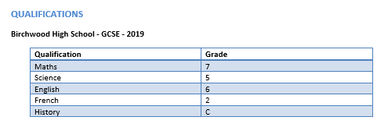
____________________________________________________________________________________________________________________________________________________________________________________________________________________________________________________________________________________________________________
Institution and Date:
Qualification | Grade

Other Qualifications:
Institution | Date | Pass Level

Voluntary and Work Experience
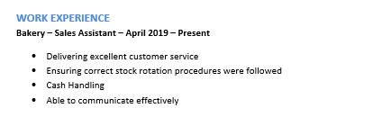
Voluntary Experience
www.do-it.org
www.vinspired.com/teen-volunteering
___________________________________________________________________________________________________________________________________________________________________________________________________________________________________________________________________________________________________________________________________________________________________________________________________________________________________________________________________________________________________________________________________________________________________________________________________________________________________________________________________________________________________
Work Experience
__________________________________________________________________________________________________________________________________________________________________________________________________________________________________________________________________________________________________________________________________________________________________________________________________________________________________________________________________

Key Achievements
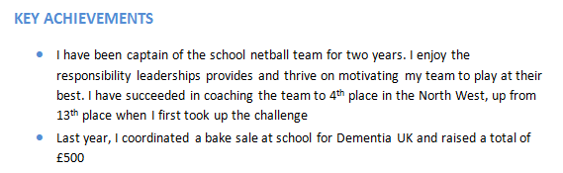
__________________________________________________________________________________________________________________________________________________________________________________________________________________________________________________________________________________________________________________________________________________________________________________________________________________________________________________________________________________________________________________________________________________________________________________________________________________________________________________________________________________________________________________________________________________________________________________________________________________________________________________________________________________________________________________________________________________________________________________________________________________________________________________________________________________________
References
Although references aren’t needed on a CV, it is useful to have these prepared for when they are required.
- Prepare two references, either academic or professional
- Will need referee’s: full name, job title, e-mail address, contact number, address of the organisation

Good Cover Letter Example
J Bloggs
2, Any Close
Any Street
Any Town
WA3 6YZ
01925 111111 (home)
0087654321 (mobile)
Email: j.bloggs@email.co.uk

Recruitment
United Utilities
Warrington

2nd June 2021

Dear Sir/Madam,

Application for Project Management Apprentice

I am writing in response to your advertisement for the position of Project Management Apprentice, job reference VAC001163913, which appeared on the .gov.uk website on 23rd May 2021.

Since a young age, I have had a keen interest in (whatever area the apprenticeship is in) and have wanted to pursue a career in this area for many years.

I am a hardworking, confident individual who enjoys a challenge and believe it is this work ethic that will enable me to be successful in my future career. Through my role as (insert extra-curricular activity) I have been able to develop my leadership and teamwork skills and prove that I can manage my time effectively to achieve success in both my academic and extra-curricular activities.

I would welcome the opportunity to meet with you to explore how my experiences and achievements meet your requirements.

Yours faithfully,

Jenny Bloggs

Writing cover letters
If you are thinking about sending over your CV quickly without a cover letter, then think again! Not only do most employers expect one, but a well-written cover letter really compliments your CV – and can boost your chances of landing an interview.
What is a cover letter?
A cover letter is a short one-page letter or email that precedes a CV, so it is your first point of contact with a prospective employer. Just as in real life, it would be poor form to launch into the details of your life experience when meeting someone for the first time. A cover letter allows you to politely introduce yourself and summarise who you are and where you’ve come from.
What differentiates your cover letter from your CV?
A cover letter and CV are usually designed to complement each other. While a CV should include detailed information about your educational background and work experience in a couple of pages, a cover letter is shorter and sharper - and expresses your interest in the job you’re applying for.
CVs are best formatted with headers and bullet points and are often devoid of tenses. A cover letter on the other hand is written in first person (e.g., “I have five years of experience working in an administrative role”) and is addressed to the person who is responsible for processing potential candidates for the position.
How to write covering letters
- Start with a brief introduction about yourself and state the purpose for writing. Ensure you mention the job you’re applying for and your interest in it.
- Give a snapshot of relevant skills, qualifications and experience that relate to the job description – basically, a few lines summarising the content of your CV.
- If you’ve claimed you have a particular skill, give real life examples. This is often required in more detail if there’s a request to meet selection criteria.
- Mention that your CV is attached, and then finish with a call-to-action, such as requesting an interview or asking to meet, before signing off cordially.
How to make your cover letter stand out from the crowd
A cover letter should interest the reader; teeing them up so they can’t wait to get to your CV to read more. Most importantly, it should show the employer that you have the skills to do the job - so always tailor your letter specifically to the role you’re applying for.
A good cover letter convinces an employer that you are what they are looking for, but will also demonstrate your written communication skills, so inject your personal style into your writing to stand out above the competition.
Some quick tips when writing your cover letters
- Use clear direct language, avoiding overly long sentences or fancy words.
- Tailor the letter to the job and company and make it clear that it hasn’t been recycled.
- Instead of writing ‘Dear Sir / Madam’, phone the company and find out who is the correct person to address it to.
- Use good spelling and grammar.
- Keep it under 250 words and make sure it fits onto one page.

Jobsites and Useful Websites

www.ucas.com
http://www.notgoingtouni.co.uk/
https://www.getmyfirstjob.co.uk/
https://nationalcareersservice.direct.gov.uk
http://www.reed.co.uk/
http://www.inputyouth.co.uk/index.php
http://www.monster.co.uk/
http://www.indeed.co.uk/
http://www.totaljobs.com/
https://www.careerbuilder.co.uk/
https://www.jobsite.co.uk/
http://www.jobs.ac.uk/
http://www.cv-library.co.uk/
http://www.fish4.co.uk/
https://www.glassdoor.co.uk/index.htm
http://www.simplyhired.com/
http://jobs.aol.com/
http://www.changeboard.com/

Higher Level Apprenticeship & the Internship Scheme at Vaultex
Higher Level Apprenticeship Scheme
Starting salary: £21,000 approx.
Pre-requisites: 180 UCAS points across 3 A Levels, not including General Studies (or equivalent).
Foundation Degree in Management & Leadership at work
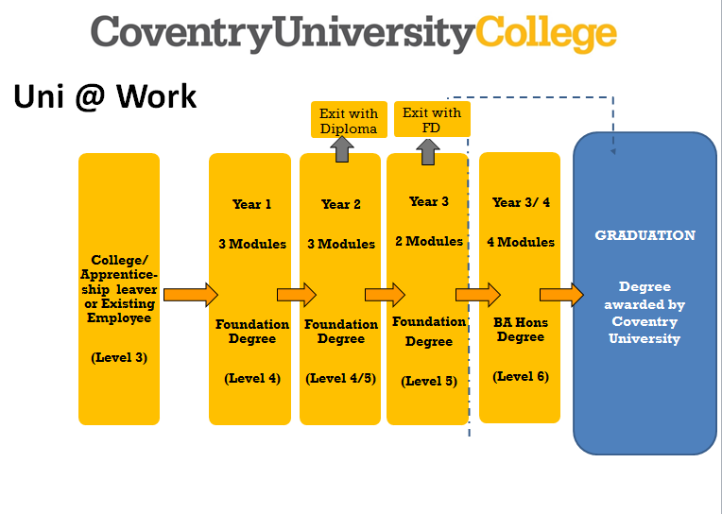
What Topics are covered?
• Marketing
• Organisational Development
• Strategic Leadership
• Delivering a Business Project on successful completion of the programme

What will my role entail?
Learning alongside managing a full-time job. The aim is to become fully competent in all processing departments whilst assisting the Regional Manager with the leadership of the region.
Summer Internship Scheme
We run a three-month paid summer internship aimed at providing work experience to those wishing to develop practical skills and further their employability in areas such as IT, HR, Finance, Transformation and Communications.
If you are interested in any of the opportunities offered by Vaultex, including Cash Processing, please email: recruitment@vaultexuk.com or contact one of us directly.

